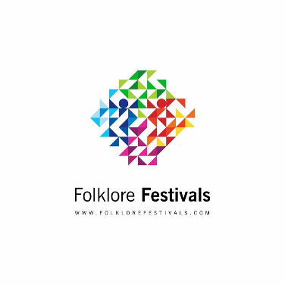

**To: (Name of the group applicant)  
(City & Country of the group applicant)  
(name of the leader of the Group)**

**Attending to: (Name of the festival Event)**

**Subject:**  Invitation Letter Date: (date)

### (Title name of the festival Event) (Date of the Festival event)

Dear Sir/Madam,

It gives us a great pleasure to inviteyourgroup to participate on the (Name of the festival event) will take place in (location of festival event/city/country)

We confirm that your group can travel to (location of festival event/city/country) to attend this festival in order to represent the culture of their country through performances held in the city of (location of festival event/city/country), in the period from (date of the festival event)

According to the festival conditions the group will be part of the festival for culture exchange and friendship.

For participating on the festival the group has agreed with the festival conditions.

Please do not hesitate to contact our team for any additional information.  
  
  
  
Yours truly,

Folklore Festivals Team